***SALES TREND & FORECAST***

1. **Total Customers wrt date:**

Create a new measure “Total Customers=sum(sales[Customers])”. Create a line chart with date in the X-axis and total customers in the Y-axis.

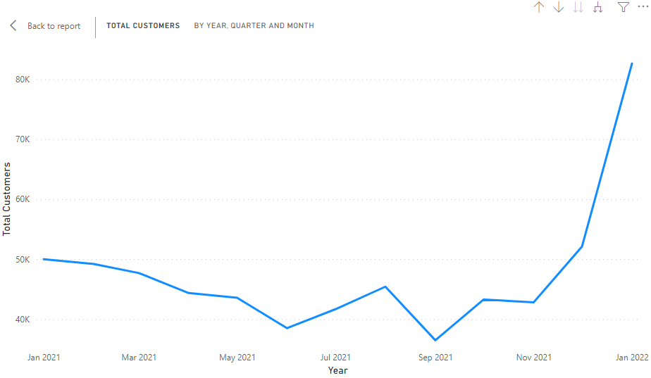

We could conclude there is a decline in the number of customers from March 2021 to June 2021 and from August 2021 to September 2021

1. **Total Amount wrt date:**

Create a line chart with date in the X-axis and total amount in the Y-axis.

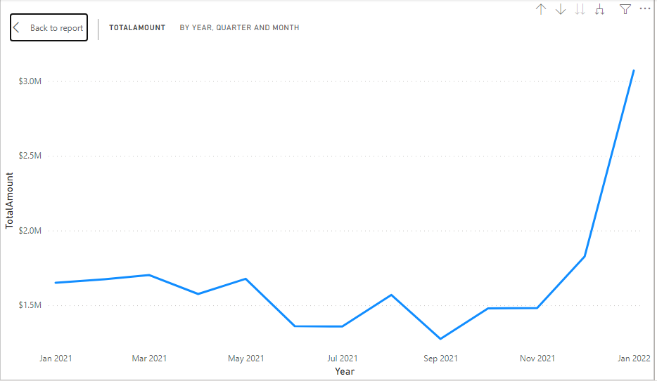

**FORECASTING DATA:**

In the line graph add the following fields

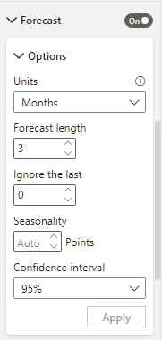

**RESULTS:**

